<<AUTOMATED CLIMATE SENSORY UNIT(ACSU)>>

An Engineering Project in Community Service

# Final Report

***Submitted by***

**<<Team Members List**

1. **19MIM10047 Sri Abhishek Mamidi**
2. **19BCG10030 Raj Kamal Patel**
3. **19BCE10265 Sanjay S**
4. **19MIM10098 Mohith Sankar**
5. **19BCY10178 Siddhu Chelluru**
6. **19MIM10090 Bommisetty Krishnah Manas**
7. **19MIM10037 Ghadiyaram Hanumath Srinivasa Dixit**
8. **19BCE10245 Pandipati Pavan >>**

***in partial fulfillment of the requirements for the degree of Bachelor of Engineering and Technology***



**VIT Bhopal University Bhopal**

**Madhya Pradesh**

# <<April, 2022>>

**Bonafide Certificate**

## Certified that this project report titled **“<< Automated Climate Sensory Unit>>”** is the bonafide work of “<< 19MIM10047 Sri Abhishek Mamidi, 19BCG10030 Raj Kamal Patel, 19BCE10265 Sanjay S, 19MIM10098 Mohith Sankar, 19BCY10178 Siddhu Chelluru, 19MIM10090 Bommisetty Krishnah Manas, 19MIM10037 Ghadiyaram Hanumath Srinivasa Dixit, 19BCE10245 Pandipati Pavan >>**”** who carried out the project work under my supervision.

This project report (Phase II) is submitted for the Project Viva-Voce examination held on …………..



# Supervisor

**Comments & Signature ( Reviewer 1)**

# Comments & Signature ( Reviewer 2)

1. **INTRODUCTION**

Due to the increasing green house gases in our environment the

danger of global warming increases day by day and make the lifes on this planet very much affected. Now-a-days, The Environment is getting polluted and there is no ecological balance in the Environment. So there are a lot of harmful and dangerous gases were getting increased and they are ringing the danger bells to all of us. Even many cities and countries are worrying about this issue and getting much affected by these harmful pollutants. This problem got raised due to the lack of less tress and got increased with Industries which releases poisonous gases every day. This results in reducing the Density of the Trees and we people should take some charges and making the environment in a cleaned manner. That's our duty. In this case, We are going to build one project that will help us to monitor and examine the Density of trees, the Air Quality Index, Etc. We will get some good results and outcomes from this project. So that we observe and maintain the density of trees in some areas.

# Motivation

Global warming has been a major concern across the globe for so many years and with increasing concerns for this the main reason which was found is the deficiency of trees in major developing or developed cities, the cities lacking in density of trees are generally the most polluted ones, continuous monitoring of trees in such cities and getting data about their pollution index can help in treating them against the odds of pollution since this work will be carried out on a large scale manual monitoring will be a tough task to do.

# Objectives

This project basically helps in determining the air quality index of the particular region we are monitoring by determining the density of trees in that particular region.

The project allows the user to chose any particular location through a google earth interface and for that particular region the user will get all the data like air quality index and a layout where a map will show the density of trees in that particular area.

# Methodology

The purpose of this project is to create a model that can predict the health of individual trees and based on that we will predict the air quality index of that particular region according to the density of trees. the task is approached by using Deep Learning Model where images of trees are collected using Google Satellite Imagery and then we recall data of collected images like pixels of the trees and size of the trees. the collected images should be in High resolution which will provide absolute data features of the trees required. Once you have the imagery, you'll create training samples and convert them to a format that can be used by a deep learning model. To provide your deep learning model with the information it needs to

extract in the image, we'll create features for a number of trees to teach the model what the size, shape, and spectral signature of trees may be. These training samples are created and managed through the Label Objects for Deep Learning tool. To make sure capturing a representative sample of trees in the area, we'll digitize features throughout the image. These features are read into the deep learning model in a specific format called image chips.

# EXISTING WORK/LITERATURE REVIEW

The main purpose of the Existing Project is to Classify the Trees using Red-Green-Blue that is using RGB Images and with the help of CNN(Convolutional Neural Network).

There is one more main aim or motto of the project is to detect a Tree with the help of Aerial High Resolution- RGB images.

Here we’ve used Deep Learning based on CNN(Convolutional Neutral Networking).

# AUTOMATED CLIMATE SENSORY UNIT

## System Design/Architecture -

Actually, we need to simplify the process or the procedure. So for that, we are going to use the Deep Learning Model to identify the trees to make the process easier.

To get this model, We need to collect and recall the images of the trees, So that it could easily collect and recall the data like Pixels of the trees and Size of the trees.

We need an absolute, accurate and even with the HIGH- Resolution Pixel Photos are required and these are more necessary and essential things for the extraction of the features.

In this method, We use a Google Satellite Imagery to collect the Images of the Forest or the Area. There are some steps involved in downloading the imagery.

As we are using the Deep Learning Model for the project, So the training of the data is more important.

The training schema is created on the basis of the classification of trees by predicting the Air Quality Index, Density, and Environmental Index.

These training samples are created and managed through the Label Objects for Deep Learning tool.

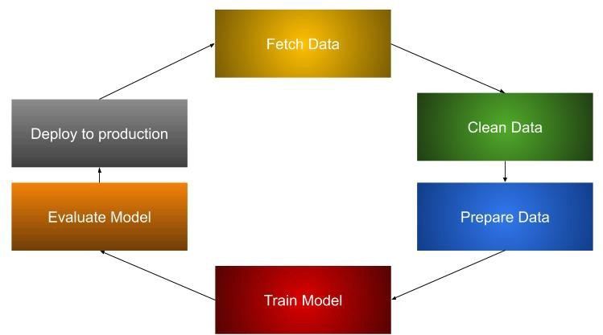

## Working Principle -

Many harmful pollutants mixed in air causes the surrounding air polluted and harmful for human beings. The main pollutants are carbon monoxide, lead, nitrogen oxides, ground-level ozone, particle pollution (often referred to as particulate matter), and sulfur oxides.

The greater the level of air pollution and the greater the health concern. For example, an AQI value of 50 or below represents good air quality, while an AQI value over 300 represents hazardous air quality.

For each pollutant an AQI value of 100 generally corresponds to an ambient air concentration that equals the level of the short-term national ambient air quality standard for protection of public health. AQI values at or below 100 are generally thought of as satisfactory. When AQI values are above 100, air quality is unhealthy: at first for certain sensitive groups of people, then for everyone as AQI values get higher.

Climate data records provide evidence of climate change key indicators, such as global land and ocean temperature increases; rising sea levels; ice loss at Earth’s poles and in mountain glaciers; frequency and severity changes in extreme weather such as hurricanes, heatwaves, wildfires, droughts, floods and precipitation; and cloud and vegetation cover changes, to name but a few.

At present, the days are getting worse and we are destroying the environment drastically.

So, to avoid these issues and problems, We developed a project which gets monitored and gives a clear information regarding the Air Quality Index, Density of the Trees, Etc.

It is more important to keep our surroundings in a clean and neat manner. That is our primary responsibility and need to maintain properly.

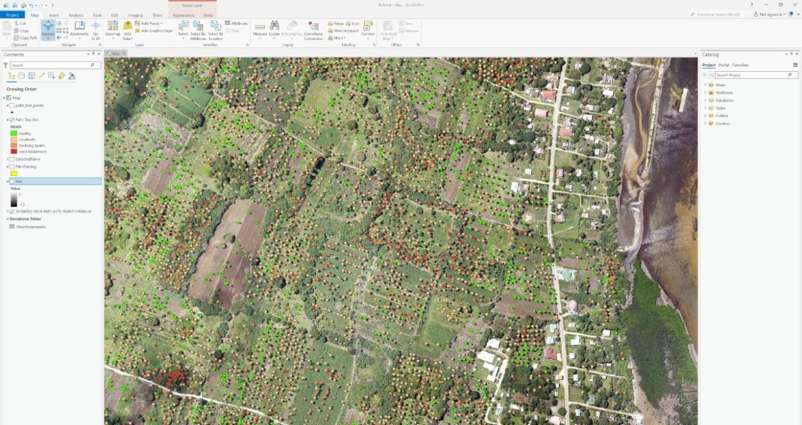

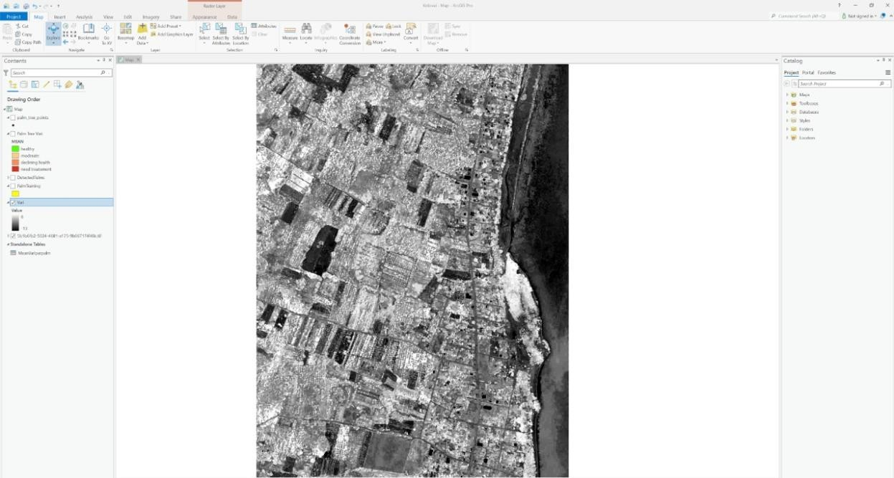

* 1. Results and Discussion - To decrease the increasing problem of pollution in many cities the project will help a lot where we will monitor the trees of certain area and detect its health and density of trees in that area and based on that air quality index will be monitored and the progress will be recorded which in result help decreasing the problem of pollution in many cities.

Whether you plant trees around your home and property, in your community, or in our national forests, they help fight climate change. Through the natural process of photosynthesis, trees absorb CO2 and other pollutant particulates, therefore monitoring of trees becomes so important as it will help in increases density of trees in cities and hence it will be beneficial against Global Warming.

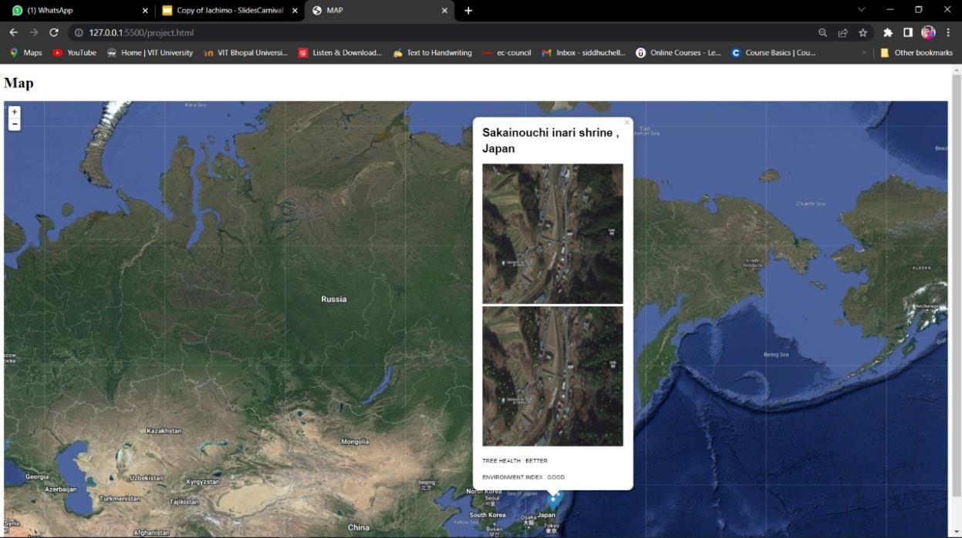

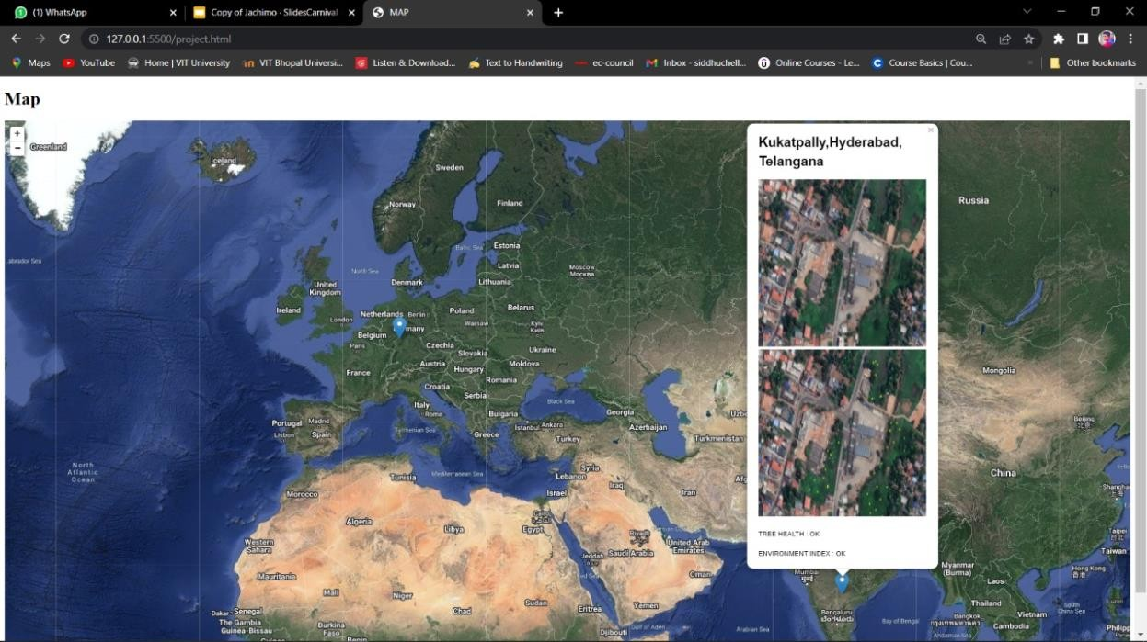

# Individual contribution by members - Individual Contribution:

**Front End Part:- Pandipati Pavan and Siddhu Chelluru**

# Back End Part:- Mohith Sankar, Ghadiyaram Hanumath Srinivas Dixit, Bommisetty Krishna Maanas, and Sri Abhishek Mamidi

**Research Work:- Sanjay S and Raj Kamal Patel**

# CONCLUSION

This project gives us an opportunity to work for the betterment of environment and giving our useful efforts to the society.

While working for this project we become familiar with many new and necessary tools for creating the model during the process of developing it.

We as a group are now more confident for our future projects we exactly know what are the requirements for making a successful project.

# REFERENCES

[**https://ethz.ch/content/dam/ethz/special-interest/baug/igp/photogrammetry-**](https://ethz.ch/content/dam/ethz/special-interest/baug/igp/photogrammetry-remote-sensing-dam/documents/pdf/Student_Theses/MasterThesis_Lang.pdf)[**remote-sensing-dam/documents/pdf/Student_Theses/MasterThesis_Lang.pdf**](https://ethz.ch/content/dam/ethz/special-interest/baug/igp/photogrammetry-remote-sensing-dam/documents/pdf/Student_Theses/MasterThesis_Lang.pdf)

[**https://learn.arcgis.com/en/projects/use-deep-learning-to-assess-palm-tree-**](https://learn.arcgis.com/en/projects/use-deep-learning-to-assess-palm-tree-health/)[**health/**](https://learn.arcgis.com/en/projects/use-deep-learning-to-assess-palm-tree-health/)

Deep Learning Research Papers and Google Maps for Tree Monitoring



|  |  |
| --- | --- |
| **Report Title:** | Automated Climate Sensory Unit |
| **Report Link:**  (Use this link to send report to anyone) | https://[www.check-plagiarism.com/plag-](http://www.check-plagiarism.com/plag-) report/725247b6517888da95cc5b97b491241e54df6165064873 |
| **Report Generated Date:** | 23 April, 2022 |
| **Total Words:** | 1513 |
| **Total Characters:** | 10188 |
| **Keywords/Total Words Ratio:** | 0% |
| **Excluded URL:** | No |
| **Unique:** | **89%** |
| **Matched:** | **11%** |